Physics 20 Lesson 17 Elevators and Inclines

# Vertical forces

## Tension

Suppose we attach a rope to a steel ball and hold the ball up by the rope. There are two forces acting on the ball: the force due to gravity and the applied force of the rope on the ball. Another name for this kind of applied force is the **tension force**.

The free body diagram for the ball is:

•

T

g

If we apply a tension force greater than the force due to gravity, the result is upward acceleration.

If we apply a tension force smaller than the force due to gravity, the result is downward acceleration.

If FT and Fg are balanced the acceleration is zero. Either the ball is at rest or it is moving with constant velocity.

A rope is attached to a 50 kg mass. What is the tension force required to accelerate the mass upward at 2.0 m/s2?

•

T

g = 50 kg(9.81 m/s2)

g = 490 N

NET = T + g

m = T + g

50 kg(+2.0 m/s2) = T + (–490 N)

T = **+590 N** or **590 N upward**

A rope is attached to a 50 kg mass. What is the tension force required to lift the mass upward at a constant speed?

•

T

g = 50 kg(9.81 m/s2)

g = 490 N

NET = T + g

0 = T + g (since  = 0, NET = 0)

0 = T + (- 490 N)

T = **+490 N** or **490 N upward**

A rope is attached to a 50 kg mass. If an upward force of 280 N is applied on the rope, what is the resulting motion of the mass?

•

T = 280 N

g = 50 kg(9.81 m/s2)

g = 490 N

NET = T + g

m = T + g

 = – **4.2 m/s2**

The mass accelerates downward at 4.2 m/s2.

## Elevators

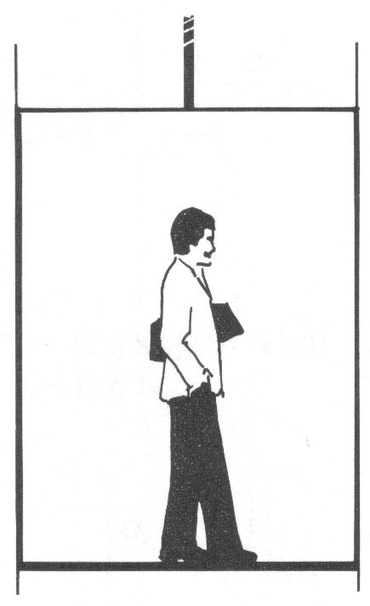

When you are standing inside an elevator you experience the effects of the motion of the elevator. When you enter the elevator and press the button, you feel the normal amount of your weight on your feet. When the elevator accelerates upward, you feel slightly heavier than normal. As the elevator continues up at constant speed you feel your normal weight again, but as the elevator slows to stop at your floor you feel slightly lighter than normal. Why do you feel different things as the elevator’s motion changes? Let us analyse this a little more closely.

•

N

g

What you feel, we call it your **apparent weight**, is not the pull of gravity down on you, rather *what you feel as your weight is the floor pushing up on you*. (If you have trouble grasping this idea, imagine what you feel your weight to be if you fall through the air. Since there is nothing pushing back at you or holding you up, you feel weightless.) In other words, the apparent weight you feel is actually the normal force of the elevator floor acting on you (Fapparent = FN). Further, the normal force changes due to the motion of the elevator floor. To see how this works, consider the equation for net force from the free body diagram.

NET = N + g

Since N acts in the (+) direction and g acts in the (–) direction we get:

NET = FN – Fg

Rearranging the equation, your apparent weight (FN) is given by the equation:

FN = NET + Fg

Inspection of the equation reveals that if you are accelerating up (FNET > 0) your apparent weight will be greater. If you are accelerating down (FNET < 0) your apparent weight will be smaller, and when you are at rest or moving at constant speed (FNET = 0) your apparent weight will be your normal weight.



If you normally weigh 706 N, what is your apparent weight if you are in an elevator that is slowing down at the rate of 1.65 m/s2?

first calculate m from Fg

•

N

g = 706 N (normal weight =

force due to gravity)

 = 72 kg

NET = N + g

N = NET – g

N = m – g = 72 kg(–1.65 m/s2) – (–706 N)

N = **587 N**

## Rockets

•

Fthrust

Fg

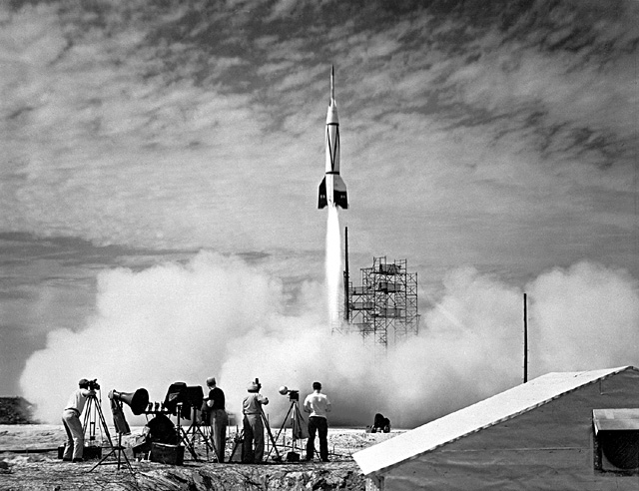The picture to the right shows the first rocket ever launched from Cape Canaveral in 1950. The thrust of a rocket does two things. (1) It overcomes the force due to gravity acting on the rocket and (2) it accelerates the rocket upward. The action force is the rocket engine pushing gases down out of the rocket. The reaction force is the gases pushing up on the rocket.

A 1200 kg rocket produces 30000 N of thrust. What is the velocity of the rocket 45 s after launch?



•





# Inclined planes

When we place an object on a horizontal surface the force of gravity acts straight down toward the centre of the Earth and the normal force acts straight up. Recall from Lessons 15 and 16 that the normal force is the reaction force of the surface to any force acting on the surface. The angle between the surface and the reaction force is always 90o (i.e. a normal angle). When the surface is horizontal, FN acts exactly opposite Fg and the net force is zero.





Now imagine that we slowly incline the surface from the horizontal to some angle . The gravitational force continues to act straight down and the normal force continues to act at 90o to the incline. But note that FN no longer acts opposite Fg.

 





Some of the gravitational force is directed **into the incline** and some is directed **down the incline**. Therefore, we break up the gravitational force (Fg) into components. One component (Fx) acts down the incline and the other (Fy) acts into the incline. Note that FN counters Fy. An analysis of the geometry (see optional section below) reveals that ** = **.





α

 





Thus if we are given the angle of inclination, the components may be calculated:





As stated above, the normal force counteracts the vertical component of the force of gravity:



A 30 kg object is on an inclined plane set at 40° to the horizontal. What is the acceleration experienced by the object if the coefficient of friction is 0.25?

+

–







40

 40









 

# Proof that  =  (optional)

From abc we know that .

Since and side are parallel, the angle between  and  is φ .

The angle between  and is 90o .



Since  and then



❑



φ

c

a

b







# Practice problems

1. A 490 N object is suspended from a rope.

a. What is the force required to raise it vertically at 5.00 m/s? (490 N)

b. What is the force required to accelerate it down at 3.00 m/s2? (340 N)

2. A 20.0 kg mass is placed on a 50o incline. If the coefficient of friction is 0.35, what is the acceleration of the mass? (5.31 m/s2)

 50o

# Hand-in Assignment

1. For each situation below, draw accurate free-body diagrams showing all forces acting on the rock.

B. Static

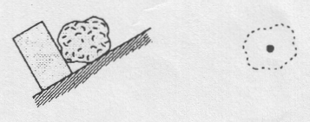

A. Static

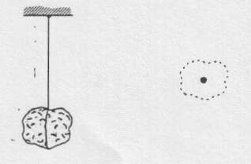

D. Static friction prevents sliding.

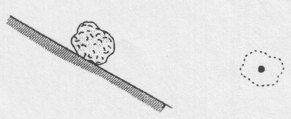

C. Sliding without friction.

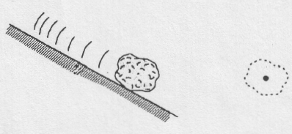

F. Tied to a rope and pulled straight upward. Accelerating upward at 9.81 m/s2 . No friction.

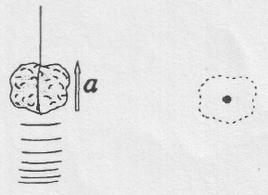

E. Static

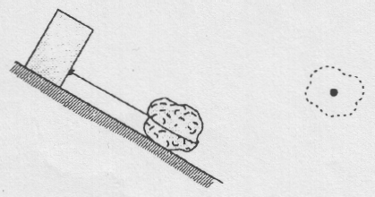

G. Tied to a rope and pulled straight downward. Accelerating downward at 19.62 m/s2. No friction.

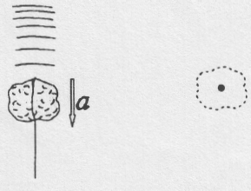

1. A rope is used to lift a 4.0 kg rock vertically up at 0.5 m/s. What is the tension in the rope? (39 N)
2. A jet accelerates vertically up at 8.5 m/s2. What force does the exhaust gas exert on the 4400 kg jet? (8.1 x 104 N)
3. A 360 N force is applied horizontally to a 150 N box which experiences a force of friction of 75.0 N. What is the net acceleration of the box? (18.6 m/s2)
4. A 2.0 kg pendulum hangs in an elevator. Calculate the tension in the string supporting the pendulum if the elevator moves:
   1. with zero velocity (19.62 N)
   2. downward at a constant velocity of 2.5 m/s (19.62 N)
   3. upward at a constant velocity of 2.5 m/s (19.62 N)
   4. downward at a constant acceleration of 2.0 m/s2 (15.62 N)
   5. upward at a constant acceleration of 2.0 m/s2 (23.62 N)
5. A man measures the acceleration of an elevator by using a spring balance. He fastens the scale to the roof, and suspends a mass from it. The scale reads 98 N when the elevator is at rest, and 93 N when the elevator is moving.
   1. What is the acceleration of the elevator? (0.50 m/s2)
   2. In which direction is the elevator accelerating? (down)
6. (Bonus) A fish hangs from a spring scale supported from the roof of an elevator. If the elevator has an upward acceleration of 1.2 m/s2 and the scale reads 200 N, what is the true force of gravity on the fish? (b) Under what circumstances will the scale read 150 N? (c) What will the scale read if the elevator cable breaks?

(1.8 x 102 N, 1.5 m/s2 down, 0)

1. A 2.5 kg object is allowed to fall down a 60o incline which has a coefficient of friction of 0.12. What is the object's acceleration? (7.91 m/s2)
2. A 10.0 kg mass is allowed to accelerate down a 20 m frictionless inclined plane. What is the block's final velocity if the incline is at an angle of 45o? (16.7 m/s)
3. A 5.0 kg mass is on an incline which makes an angle of 50o with the horizontal. The incline has a coefficient of friction of 0.10.
   * 1. If the mass is released from rest, at what rate does it accelerate down the incline? (–6.88 m/s2)
     2. What force must be applied to cause the mass to accelerate at 2.0 m/s2 **up** the incline? (50.65 N)